Week 1

* An ecosystem is a group of elements that interact to produce, manage, store, organize, analyze, and share data.
* Data can be found in something called the cloud, rather than on a computer hard drive.
* Data science is defined as creating new ways of modeling and understanding the unknown using raw data.
* Data analysis is the collection, transformation, and organization of data to draw conclusions, make predictions, and drive informed decision making.
* Data analytics, in the simplest terms, is the science of data.
* Data-driven decision making is defined as using facts to guide business strategy.
* Data alone will never be as powerful as data combined with human experience, observation, and intuition.

Analysts use data-driven decision-making and follow a step-by-step process. You have learned that there are six steps to this process:

* **Ask** questions and define the problem.
* **Prepare** data by collecting and storing the information.
* **Process** data by cleaning and checking the information.
* **Analyze** data to find patterns, relationships, and trends.
* **Share** data with your audience.
* **Act** on the data and use the analysis results.

# Week 2

* Analytical skills are qualities and characteristics associated with solving problems using facts.
* There are several aspects to analytical skills; however, here we will focus on the following five essential points, which are curiosity, understanding context, having a technical mindset, data design, and data strategy.
  + Curiosity is all about wanting to learn something.
  + Context is the condition in which something exists or happens. Understanding the context is crucial.
  + A technical mindset involves the ability to break down things into smaller steps or pieces and work with them in an orderly and logical way.
  + Data design is how you organize information, just like the way you organize the contacts on your phone.
  + A data strategy is a management of the people (they know how to use the right data to find solutions), processes (the path to that solution is clear and accessible), and tools used in data analysis (the right technology is being used for the job).

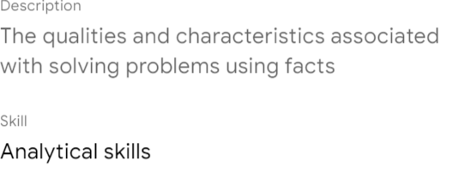

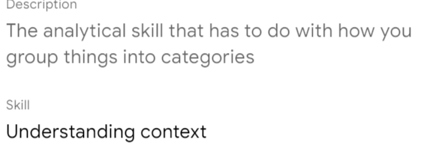

* Analytical thinking involves identifying and defining a problem before solving it. Its five key aspects are visualization, strategy, problem-orientation, correlation, and big-picture and detail-oriented thinking.
* To solve a problem, we use data in an organized, step-by-step manner.
* Data analysts use a problem-oriented approach to identify, describe, and solve problems. They could identify correlations between two or more pieces of data.
* A correlation is like a relationship; it does not equal causation.
* Big-picture thinking helps you zoom out and see possibilities and opportunities, while detail-oriented thinking is about figuring out all aspects that will help you execute a plan.
* There are all kinds of problems in the business world that can benefit from employees who have a big-picture and detail-oriented way of thinking.
* The more ways you can think of, the easier it is to think outside the box and come up with fresh ideas.
* In data analysis, solutions are seldom right in front of you.
* You might naturally be an analytical thinker, but you can learn to think creatively and critically.
* The Five Whys can reveal some surprising root causes for data analysis.
* Root cause: the reason why a problem occurs
* Gap analysis lets you examine and evaluate how a process works currently to get to where you want to be in the future.
* Businesses conduct gap analysis to do all kinds of things, such as improve a product or become more efficient.
* The way data analysts think and ask questions affects how businesses make decisions.
* In business, data-driven decision-making can improve results in different ways.
* Data analysts can tap into the power of data to do all kinds of amazing things. They can gain valuable insights and verify their theories or assumptions.
* Data-driven decision-making increases your confidence in your decision and ability to address business challenges. It helps you to become more proactive when an opportunity presents itself, and it saves you time and effort when working toward a goal.
* Data analysts use context to make predictions, research answers, and draw conclusions.
* A data strategy incorporates the people, processes, and tools used to solve a problem. It gives you a high-level view of the path you should take to achieve your goals.
* It is much more likely to be successful if everyone is on board and on the same page; thus, it is important to ensure that specific procedures are in place.
* Google's HR department wanted to know whether there was any value in having managers. It looked at past performance reviews and employee surveys.
* The Googlers had positive feelings about their managers. This confirmed that managers were valued and made a big difference.
* Employees could nominate their favorite managers for what makes a great manager.
* This data-driven decision continues to create an exceptional company culture for most of them.
* Nonprofits are organizations dedicated to advancing a social cause or advocating a particular effort, such as food security or education.
* The data analysts used a tracker to monitor story topics, clicks, web traffic, comments, shares, and more.

# WEEK 3

* The data analysis process includes the following phases
  + asking
  + preparing
  + processing
  + analyzing
  + sharing
  + acting
* Data analysis tools include
  + spreadsheets
  + databases
  + query languages
  + visualization software
* The stages in the life cycle help us to understand the individual phases that data goes through before starting the project analysis.
* The life cycle of data is to plan, capture, manage, analyze, archive, and destroy it.
* The first phase is planning which needs to answer the below questions:
  + what kind of data does it need?
  + how it will be managed throughout its life cycle?
  + who will be responsible for it, and the optimal outcomes.
* The next phase is when you capture data and bring them into the organization.
* The data life cycle has now evolved to the archive phase. Archiving means storing data in a place where it is still available but may not be used again.
* The data is used to solve problems, make great decisions, and support business goals. This is where data analysts really shine.
* The last step in the lifecycle is destroying, it is important for protecting a company's private information, as well as private data about its customers.

You learned that there are six stages to the data life cycle. Here is a recap:

1. **Plan:** Decide what kind of data is needed, how it will be managed, and who will be responsible for it.
2. **Capture:** Collect or bring in data from a variety of different sources.
3. **Manage:** Care for and maintain the data. This includes determining how and where it is stored and the tools used to do so.
4. **Analyze:** Use the data to solve problems, make decisions, and support business goals.
5. **Archive:** Keep relevant data stored for long-term and future reference.
6. **Destroy:** Remove data from storage and delete any shared copies of the data.

* Data analysis is not a life cycle; it is the process of analyzing data.
* Working with stakeholders is the best way for asking effective questions and for defining the problem in question.
* Stakeholders: people who have invested time and resources into a project and are interested in the outcome.
* The previous statement is a part of the “ask” phase. The first step is to determine who the stakeholders are. It helps you focus on the problem itself and not only on its symptoms.
* The “share” phase and the visualization are a data analyst's best friends.

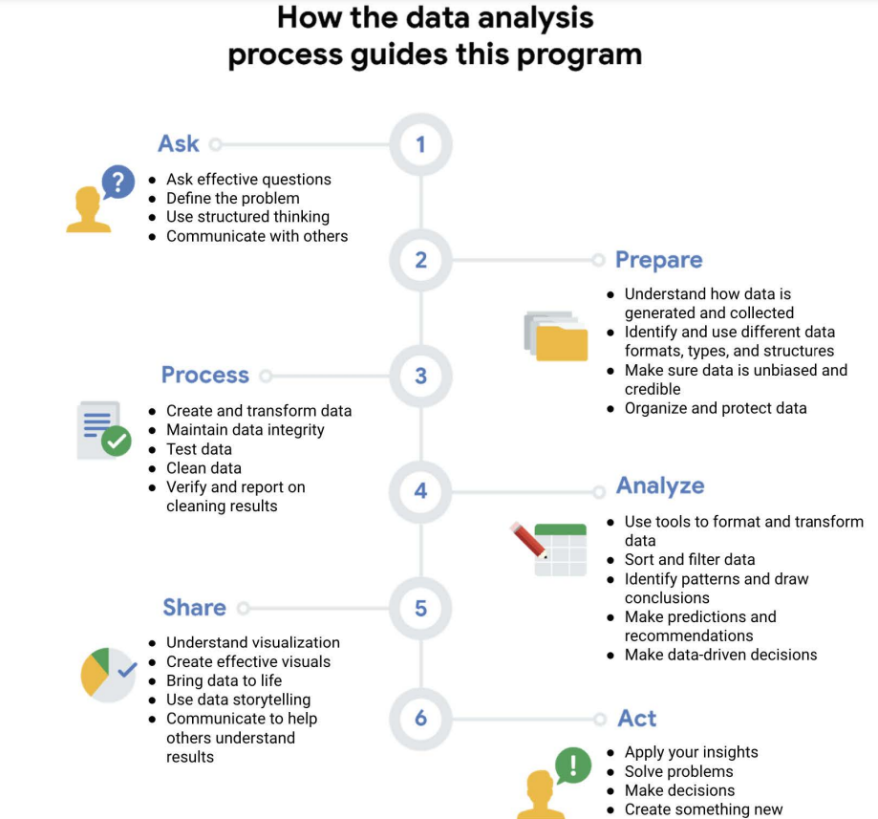

* The first thing you want to do is to ask, “What is the problem that we are trying to solve,” “What is the purpose of this analysis,” and “What are we hoping to learn from it?”

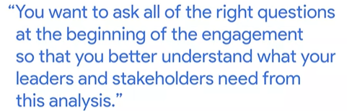

* We need to think about what type of data we need to answer those key questions.
* After you have done all the hard work of collecting your data, now, you should process that data. The first step is cleaning.
* Data analysts are trained to look for patterns, but the data are not our story to tell. This is the point where we must take a step back and let the data speak for themselves.
* We might have a sneaking suspicion as to what the data will tell us.
* The next step is to share all the data and insights that you have generated from your analyses. This is where we use all those data-driven insights to decide which types of interventions we want to introduce.
* The most common tools you will see analysts use are spreadsheets, query languages, and visualization tools. These tools allow analysts to be more focused on maximizing everything the former could do, streamlining their reporting, and just making their work simpler.
* A formula is a set of instructions that perform a specific calculation using the data in a spreadsheet. It can do basic things, such as add, subtract, multiply, and divide, but they do not stop there.
* A function is a preset command that automatically performs a process or task using data.
* Search Query Language (SQL) is a data analysis tool.
* Data analysts prefer using Tableau because it helps them create visuals that are very easy to understand. The latter gives them an easy way to create visuals based on the results of a query.
* With Looker, you can give stakeholders a complete picture of your work by showing them visualization data and the actual data related to it.

# Week 4

* Attribute: in a table, an attribute is a characteristic or quality of data used to label a column.
* Search Query Language (SQL) can do most things that spreadsheets can do.
* Think of SQL as a supersized spreadsheet. You can use it to store, organize, and analyze data.
* A query is a request for data or information from a database. With this query, we can select specific data from the table and filter the data based on certain conditions.
* Once you select the dataset with the help of an asterisk, the database calls up the table we need.

# Week 5

* Many businesses require data analysts.
* Real companies are already using data analytics to stay ahead of the curve.
* Data is changing the way Coca-Cola approaches its marketing strategies.
* Coca-Cola and Google use data to improve their operations and make better decisions.
* Small businesses are also starting to take advantage of data-driven insights to improve their operations and make better decisions.
* There are many ways in which companies in different industries put data to use. However, they can only do that if they have a reliable data analyst.
* As a data analyst, you will tackle business tasks that help companies use data.
* A business task is the question or problem that data analysis answers for business.
* Coca-Cola had a question about its new products. Data analysis gave them insights into new flavors that customers already like.
* Data-driven decision-making is when facts discovered through data analysis are used to guide business strategy.
* Data analytics provide the information needed to find the best possible solution to a problem.
* With data, we have a complete picture of the problem and its causes, which lets us find new and surprising solutions we never would have been able to see before.
* When it comes to data ethics, it is not just about minimizing harm but the concept of beneficence.
* We should ensure that there are actionable ways where people can consent to give that data and ways that they can ask for it to be revoked or removed.
* Data are growing, and simultaneously, we should empower people to have control over their data.
* With the knowledge that data are growing, these issues become more important to think about.

Data analysts can ensure fairness by considering inclusive sample populations, social context, and self-reported data.

To name a few others that sound similar but may not be the same role:

* Business analyst — analyzes data to help businesses improve processes, products, or services
* Data analytics consultant — analyzes the systems and models for using data
* Data engineer — prepares and integrates data from different sources for analytical use
* Data scientist — uses expert skills in technology and social science to find trends through data analysis
* Data specialist — organizes or converts data for use in databases or software systems
* Operations analyst — analyzes data to assess the performance of business operations and workflows

